**Equivalent Fractions Made Simple: A Beginner's Guide**

Fractions are numbers that are used to represent parts of wholes. Sometimes that have dissimilar numerators and denominators can represent the same amount. Such fractions are known as equivalent fractions. Let’s learn how to identify such equivalent fractions and how to generate them with step-by-step examples.

**Equivalent fractions**

The following diagrams show a fraction wall. Could you use the fraction wall to find out fractions that are equivalent to ⅔?

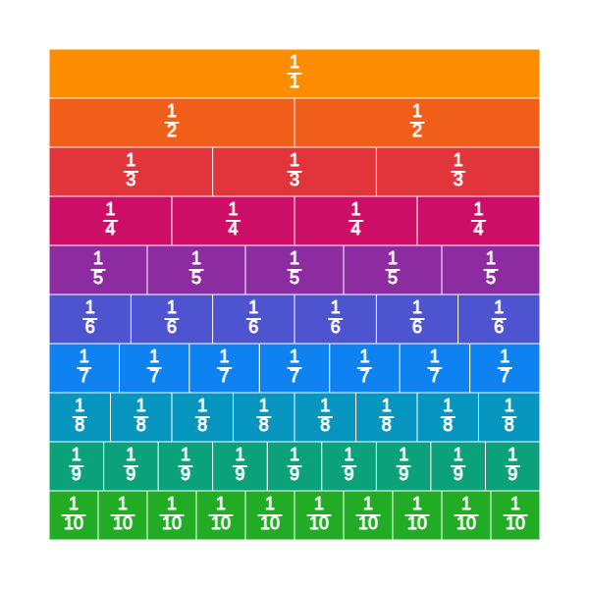

If we shade ⅔ on the bar that is split into 3 parts, and compare it with the rest of the bars, we can see that 4/6 and 6/9 will be portions of the bar that are of equal amount (length). ⅔ , 4/6, and 6/9 are therefore equivalent fractions.

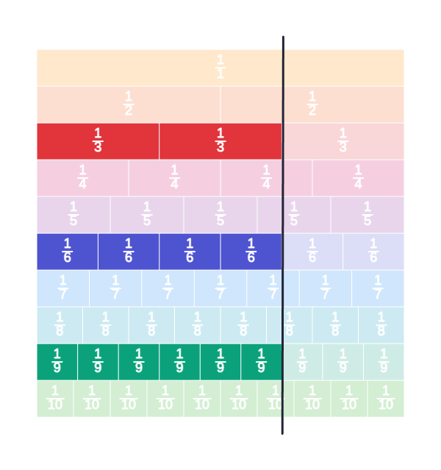

We can understand this using fraction circles too. The first represents ¾ of a circle, and the second is 9/12, but both sectors indicate the same part of the circle. Hence ¾ and 9/12 are equivalent.

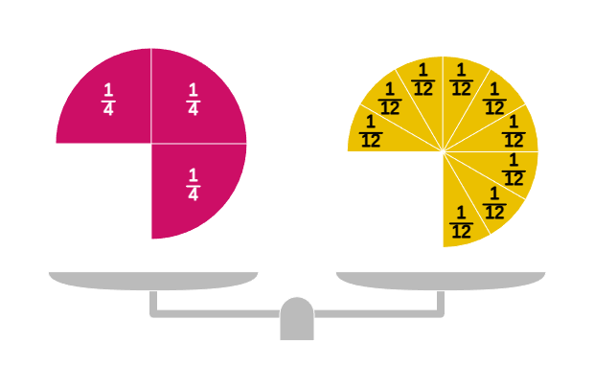

**Identifying equivalent fractions**

To determine if two fractions are equivalent fractions, we can use a fraction wall or represent it using fraction circles as illustrated earlier. But this may not always be feasible. Imagine having to draw a fraction circle or fraction bar to indicate 12/77, it would be impractical to draw a bar with 77 identical segments or a circle with 77 equal slices.

Let’s try to identify properties of equivalent fractions

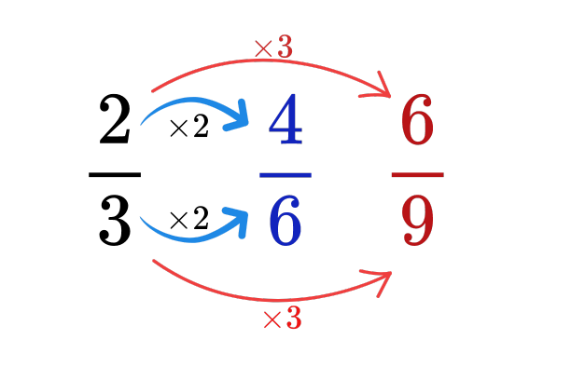

You can see that multiplying the numerator and denominator of $\frac{2}{3}$ by 2 results in $\frac{4}{6}$, and by 3 results in $\frac{6}{9}$. So if it is possible to obtain a fraction by multiplying the numerator and denominator by a whole number, then it can be identified as equivalent. This concept is used when you need to generate equivalent fractions.

**Generating equivalent fractions**

We can generate equivalent fractions by multiplying or dividing both the numerator and the denominator of a fraction by a number. For example, let’s consider the fraction 4/10. The following illustration shows how we can generate two equivalent fractions.

* One of the equivalent fractions is generated by dividing the numerator and denominator by 2.
* The second equivalent fraction is generated by multiplying the numerator and denominator by 3.
* There are many other equivalent fractions that you can generate using this rule.

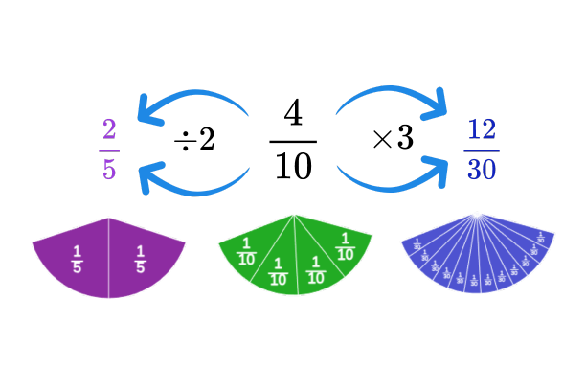

**Simplest equivalent form**

The simplest equivalent form is the equivalent fraction of a fraction with the smallest integers as the numerator and denominator. To simplify a fraction to its lowest equivalent form we can repeatedly divide the numerator and denominator by their common factors until we can’t anymore.

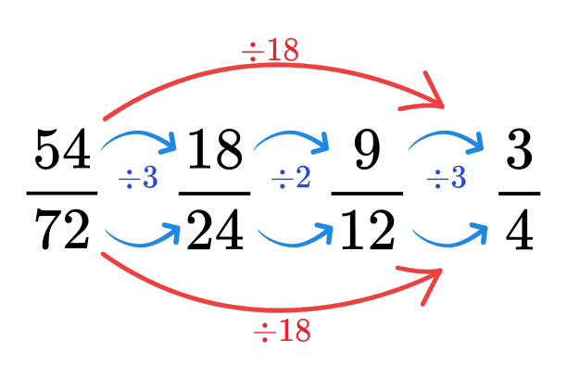

Instead of dividing repeatedly, we can divide the numerator and denominator by the LCM to directly obtain the fraction in its lowest equivalent form. As shown above, the LCM of 54 and 72 is 18, hence we can divide 54 and 72 by 18 to generate the simplest equivalent fraction of 54/72.